Paraffin Embedding Submission Request Guidelines:
- Tissue must be fixed prior to submission
  - Technical staff suggests fixing in 10% Neutral Buffered Formalin for a minimum of 4 hours
    - Time allowed in fixative should correlate with the size of the tissue
    - Type of fixative should correlate with subsequent studies
  - Please contact technical staff in advance for use of special fixatives especially in regards to antigenicity on tissue
- Tissue must be submitted in labeled cassettes and in a container sealed with a lid
  - Cassettes:
    - Technical staff recommend using Tissue – Tek Uni Cassette by Sakura Finetek (VWR catalog#14221-384)
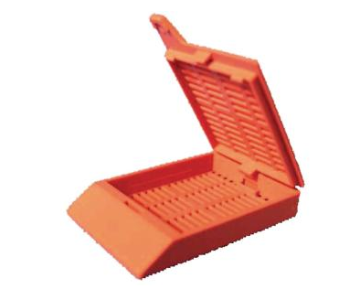
    - Cassette should be labeled legibly using a pencil or StatMark pen by Electron Microscopy Sciences (VWR catalog#101764-992). Labeling should be limited to only the specimen number and lab identifier (PI or lab name). Example below:
PI/Lab Name
Specimen#
Side Front

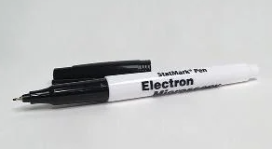
  - Tissue:
    - Grossing of the tissue is the responsibility of the requester and should be as close as possible to the area of interest. If necessary, mark the desired section with ink such as Tek – Select Tissue Marking Dyes by IMEB INC MS (VWR catalog#103783-054). Technical staff is available for assistance if necessary.
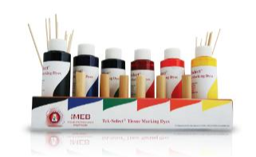
    - Any sutures, staples, etc. used during fixation should be removed for ease of microtomy. This will allow for the best sections possible
    - Tissue should be oriented in the cassette to reflect exactly it should be oriented during embedding on top of either card stock such as Pacon Array Card Stock (VWR catalog#500004-264) or Biopsy Foam Pad by VWR International (VWR catalog#18000-262) that fills the cassette
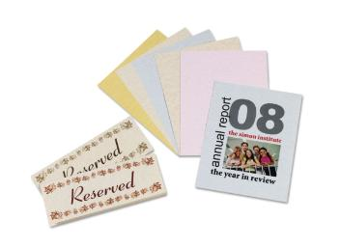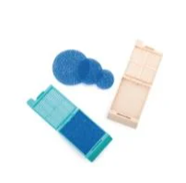
      - REMEMBER: the cutting face is at the bottom of the mold
  - For special requests please contact technical staff
- Prior to submitting a request, an appropriate request form should have at least the top portion filled out to the best of your ability and emailed to histocore@musc.edu with a brief description of the request (i.e. how many blocks, how many slides, what type of stain). After the request is received a technical staff member will contact you with a time to drop of specimens.
- Immunohistochemical staining will be performed on an automatic stainer, Leica Bond III, to provide consistent results. Stains can be done manually upon request. Requests should include:
  - Primary antibodies provided by the lab, investigator, or sponsor of the study
    - If possible, technical staff recommends using antibodies provided by Leica that come in either concentrate or ready to use that have been validated by the company for use on their machine. This will ensure the best and most consistent staining.
  - A data sheet from the supplier
- When submitting a request please provide a way in which to transport slides upon completion such as folders, trays, or slide cases. If a way to transport slides back are forgotten, the Core is able to provide a temporary folder, tray, or slide case that must be brought back within the day. If not returned by the end of day, a late fee will be added.. Examples below:
  - Folders: VWR Micro Slide Trades, Cardboard by VWR International (VWR catalog#82020-913)
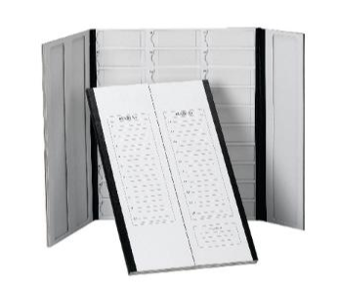
  - Trays: Hard Plastic Microscope Slide Tray by Electron Microscopy Sciences (VWR catalog# 102097-584)
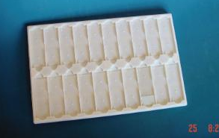
  - Slide Cases: VWR Economy Microscope Slide Boxes by VWR International (VWR catalog#82024-612)
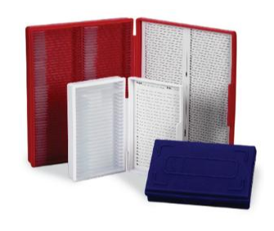
Invoices will be sent at the end of the month. Please contact technical staff for any questions or concerns regarding billing charges.

