Faculty Mentoring in Challenging Times: A Call to Action

Marc I. Chimowitz, MBChB
Professor of Neurology
Associate Dean of Faculty Development, COM
Medical University of South Carolina

President Cole, Provost Sothmann, College Deans, President Smith of the Faculty Senate, Reverend Wilson, honorees, and colleagues. I’d like to thank the Provost for that kind introduction as well as the convocation committee for inviting me to present this year’s keynote address. I am very honored and grateful to have this opportunity to present to my co-faculty on the important topic of faculty mentoring.
I’d like to start my presentation by reading a quote from a paper by Steven Lowenstein and colleagues at the University of Colorado that describes the typical activities of faculty at academic medical centers: These are, and I quote, “the element of repose, the quiet pursuit of knowledge, the friendship of books, the pleasures of conversations, the advantages of solitude”, ¹ and, I added this to the quote, “NIH funding at the 35th percentile”. Would you all agree that is an accurate description of our current work environment? I see you all shaking your heads no.

Sadly, very few of us had the good fortune of working in that era. That quote on academic life was by Dr. Arnold Rice Rich, Chair of Pathology at Johns Hopkins in the 1950’s, who was world renowned for his work on the pathogenesis of tuberculosis. ^{2,3} Dr. Rich, whose research was funded entirely by Hopkins, abhorred the concept of federal grants in part because he refused to modify his research to accommodate the opinions of reviewers. ^{2,3} Wouldn’t that be nice? He also had interesting work hours coming into the office around noon and working late into the night. ^{2,3}

Today’s climate at academic medical centers is very different: In order to balance the books, faculty face enormous pressure to generate more revenue by seeing increasing numbers of patients and writing multiple grants, while administrative demands and regulatory requirements keep increasing. This has made it increasingly difficult for faculty to find time to teach and maintain their scholarly productivity, let alone balance work and family life. ¹

These challenging times have led to some concerning trends nationwide in the movement of faculty in and out of academics. Many faculty are leaving academics, with some studies showing that up to 40% are considering leaving in the next 5 years‬. ¹ Nationwide, medical school faculty turnover is about 8-10% per year, and is especially high among women, minorities and clinicians.‬ ^{1,4} The cost of this turnover is very high, with estimates in the range of $110,000 to over $900,000 to replace each faculty member‬‬‬. ^{1,4} ‬‬‬
And compounding the loss of existing faculty is that the pipeline of new clinical and translational researchers is diminishing to the point that NIH is very concerned about the future of clinical and translational research in the USA. ‬‬‬‬‬

The net result of these trends is that there is an expensive war for talent taking place amongst academic medical centers. ⁵ In order for MUSC to be on the winning side of this war, it is imperative that we make mentoring and career development of our junior faculty a major priority. Not only is this the right thing to do for our faculty, but it also makes good economic sense for our departments and institution as a whole.

Fortunately, the leadership at MUSC has recognized this and has supported the development of several programs to improve mentoring across campus over the last 5 years. These include formation of a mentor leadership council consisting of senior and some junior faculty from all the colleges to help develop and implement mentoring programs across campus. One of the first tasks of the mentor leadership council was to develop a framework for departmental mentoring plans that has now been implemented in virtually all departments in all colleges across campus. These plans are overseen by the Associate Deans of Faculty Development in each college. A K to R club has been formed to synergize the mentoring activities across the various NIH funded K12 grants on campus, and the Society for Clinical Research and Translational Early Scientists (or SOCRATES) was also created to provide a forum for junior investigators to meet and present their research to senior faculty. The Advancement, Recruitment and Retention of Women (ARROW) program was developed to support female faculty across all missions and colleges of MUSC. Additionally, an ARROWS Center has been formed in the College of Medicine to support female faculty doing scientific research. Mentor training programs have been developed that include an annual mentor training symposium sponsored by SCTR and the monthly Tools for Mentors and Mentees series supported by SCTR and the Apple Tree Society.
There are plans to add some other mentoring programs: In the spring of 2016, SCTR will initiate an annual mentor training course to help faculty acquire the necessary tools and skills to become more effective mentors. Additionally, the KL2 program in SCTR will be leading a consortium of KL2 programs at other CTSAs in the South East to provide externships and mentoring opportunities to our KL2 scholars in areas of particular strength at these institutions. And the recently formed Academy of Medical Educators in the College of Medicine is being expanded and will help mentor faculty in the clinician-educator and investigator-educator tracks.
While the existing programs have been successful, they can only take us so far. Ultimately, the most important components of successful mentoring are the effectiveness of each mentee – mentor relationship and the willingness of our senior faculty to mentor junior faculty. We are fortunate to have some very passionate and committed mentors at MUSC who have had an enormous impact on the institution. To illustrate this, I have chosen two examples from two different colleges at MUSC.
Over her distinguished career at MUSC, the late Maralynne Mitcham, who has a special place in my heart as a fellow Zimbabwean, helped nurture and grow a very supportive environment for faculty in the College of Health Professions. Her mentees (shown in Figure 1) have had very successful careers and gone on to leadership positions at MUSC. In fact, one is now the Dean of the College of Health Professions.
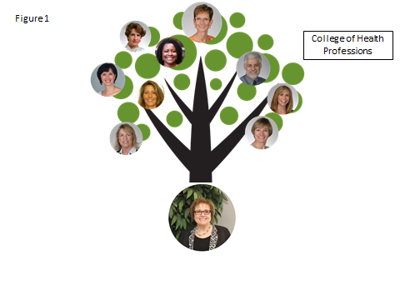
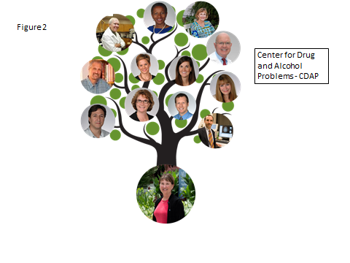
In the College of Medicine, Carrie Randall grew one of the most successful research programs at MUSC, the Center for Drug and Alcohol Problems (or CDAP) by mentoring numerous faculty in the Department of Psychiatry. These faculty (shown in Figure 2), who haven’t done too badly for themselves either, have followed in the footsteps of Carrie and are now some of the most successful mentors and leaders on campus.
The legacies that Carrie and Maralynne left are truly remarkable.
So who is going to take over the mentoring mantle from Maralynne, Carrie and their very successful mentees? Thankfully we have others and we will be honoring two of them, Dr. Michael Zile and Dr. Dennis Watson, later in this ceremony with the 2015 Peggy Schachte Research Mentors Awards. Congratulations to both of you for your outstanding contributions to mentoring and faculty development at MUSC.
But in order to grow other successful research, educational, and clinical programs at MUSC, we need more faculty to become passionate and successful mentors. As faculty, our responsibilities are not only to provide the best clinical care to our patients, make new scientific discoveries, and teach our students and trainees. We also have an obligation to nurture our junior faculty to ensure that we have a strong pipeline of expert clinicians, educators and researchers who will become the mentors of subsequent generations of faculty.
I call on each of us, especially the senior faculty, to take on this responsibility and leave their legacies of successful mentees, as Maralynne and Carrie did. I recognize that you are all busy but it is critical to carve out the time for your mentees. And there are now successful mentoring programs on campus, as I have described earlier, that can assist you in this effort.
But successful mentoring is by no means the sole responsibility of the mentors. Mentees need to be pro-active in the mentoring process. Despite their junior positions, mentees should not just be passive recipients of the mentors’ advice but should be active participants who ensure that their career development needs are being met. Mentees need to learn to manage up. And there are several programs on campus that the mentees should take advantage of such as SOCRATES, the Academy of Medical Educators, ARROW, and ARROWS.
Finally, and most important, it is key that our leadership continue to promote and support the culture of mentoring that has developed and continues to evolve on campus and make mentoring one of our priority missions. By us all making mentoring a priority, we will win the war for talent. Can you imagine how high we could climb?
References
- Lowenstein SR, Fernandez G, Crane LA. Medical school faculty discontent: prevalence and predictors of intent to leave academic careers. BMC Med Educ. 2007 Oct 14;7:37. PubMed PMID: 17935631; PubMed Central PMCID: PMC2194670.
- Heptinstall RH. Johns Hopkins Pathology: Our History. pathology.jhu.edu/department/about/history/rich.cfm
- Oppenheimer EH. Arnold Rice Rich 1893-1968. A biographical memoir. http://www.nasonline.org/publications/biographical-memoirs/memoir-pdfs/rich-arnold.pdf
- Demmy TL, Kivlahan C, Stone TT, Teague L, Sapienza P. Physicians' perceptions
of institutional and leadership factors influencing their job satisfaction at one
academic medical center. Acad Med. 2002 Dec; 77(12 Pt 1):1235-40. PubMed
PMID:12480634
- Fox S, Corrice A. Mentoring in Academic Medicine: The Current State of Practice and Evidence-based Alternatives. https://www.aamc.org/download/257862/data/mentoring_in_acadmed_current_state.pdf

