Frozen Sectioning Request Guidelines:
- Tissue must be frozen and embedded in OCT prior to submitting, as technical staff will not be responsible for the orientation of the tissue. Technical Staff recommend Tissue – Tek Cryomolds by Sakura Finetek (VWR catalog# 15160-215)
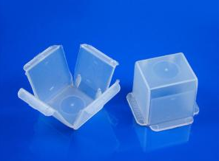
  - Technical staff recommend freezing the tissue using the following methods:
    - Snap Freezing Method:
      - Block Dry Ice – in a Styrofoam container, insert a block of dry ice (-78.5ºC). Place mold with tissue directly on block of dry ice and allow to freeze
      - Pellet Dry Ice and Isopentane – place pellet dry ice in a Styrofoam container and insert a metal bowl or glass beaker in the center of the dry ice. Under a fume hood, place some dry ice pellets in the bowl or beaker and slowly add isopentane. After the dry ice stops bubbling, a “slurry” will form. Place OCT mold with tissue in this mixture and allow to freeze
      - Dry Ice or Liquid Nitrogen – using a metal block with a flat surface, chill block in -80ºC freezer, dry ice, or liquid nitrogen. Place OCT mold with tissue on block and allow to freeze
      - Liquid Nitrogen and Isopentane – similar to using dry ice pellets, put liquid nitrogen in a Styrofoam container. Place a metal bowl or glass beaker in the center. Under a fume hood, add isopentane to bowl or beaker. When the isopentane is close to freezing, it will turn opaque. Remove from liquid nitrogen and insert OCT mold with tissue in isopentane and allow to freeze
      - Liquid Nitrogen, Vapor – in a container with a wide opening place embedding mold in the vapor phase of the liquid nitrogen
    - Fixation:
      - Formaldehyde (not recommended for immunofluorescence staining due to auto fluorescing) – after fixing tissue in formaldehyde according to protocol, rinse tissue with PBS for 10 minutes 3 times. Transfer tissue to 15% Sucrose in PBS at 4ºC until the tissue sinks to the bottom. Transfer tissue to 30% Sucrose in PBS at 4ºC until the tissue sinks to the bottom. It is very important to remove all liquid from the tissue using a kimwipe. If moisture is not removed, sections will not cut. Once all liquid is removed, place tissue in OCT mold and freeze according to protocol.
- Frozen molds should be labeled legibly with a sharpie or StatMark pen by Electron Microscopy Sciences (VWR catalog#101764-992) Labeling should be limited to only the specimen number and lab identifier (PI or lab name). Molds should be delivered in a Styrofoam cooler with a coolant such as pellet ice, dry ice, or liquid nitrogen. Example of mold labeling below:

Side Sample ID Front
PI/Lab Name

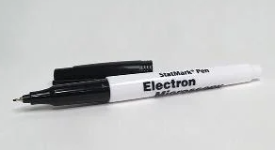
- Prior to submitting a request, an appropriate request form should have at least the top portion filled out to the best of your ability and emailed to histocore@musc.edu with a brief description of the request (i.e. how many blocks, how many slides, what type of stain). After the request is received, a technical staff member will contact you with a time to drop off specimens.
- When submitting a request please provide a way in which to transport slides and blocks upon completion such as folders, trays, or slide cases and a cooler. If a way to transport slides back are forgotten, the Core is able to provide a temporary folder, tray, or slide case that must be brought back within the day. If not returned by the end of day, a late fee will be added. Examples below:
  - Folders: VWR Micro Slide Trades, Cardboard by VWR International (VWR catalog#82020-913)
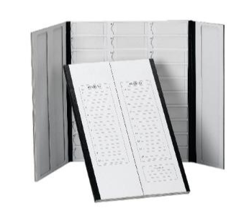
  - Trays: Hard Plastic Microscope Slide Tray by Electron Microscopy Sciences (VWR catalog# 102097-584)
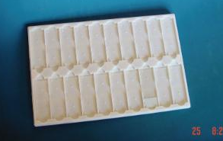
  - Slide Cases: VWR Economy Microscope Slide Boxes by VWR International (VWR catalog#82024-612)
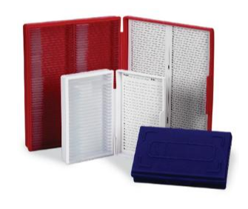
    - Slide cases are recommended for tissue sections that are to remain frozen until ready to use by the requesting lab

Invoices will be sent at the end of the month. Please contact technical staff for any questions or concerns regarding billing charges.

